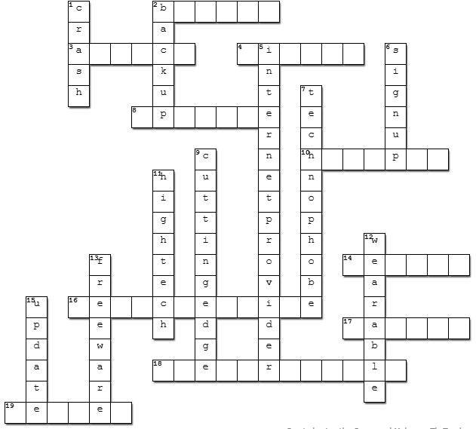
Handout 03: Crossword A

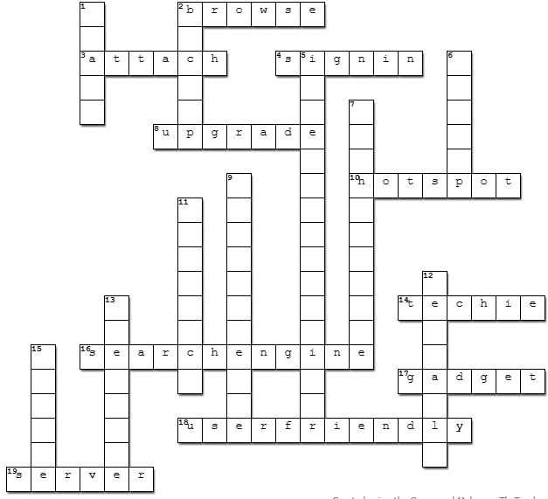
Handout 03: Crossword B

Handout 03: Crossword A (A2)

1. Better/new
2. Look around
3. New
4. Doesn’t like technology
6. Sky, Virgin, Vodafone
8. Loves tech
9. Software
11. Latest/newest
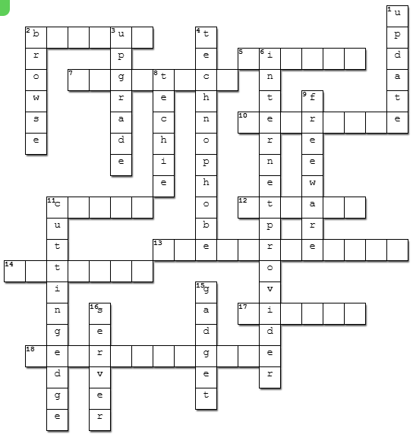
15. Smartwatch
16. Central computer

Handout 03: Crossword B (A2)

2. Backup
5. New account
7. Very advanced
10. Smartwatch
11. Stop working
12. Add
13. Easy to use
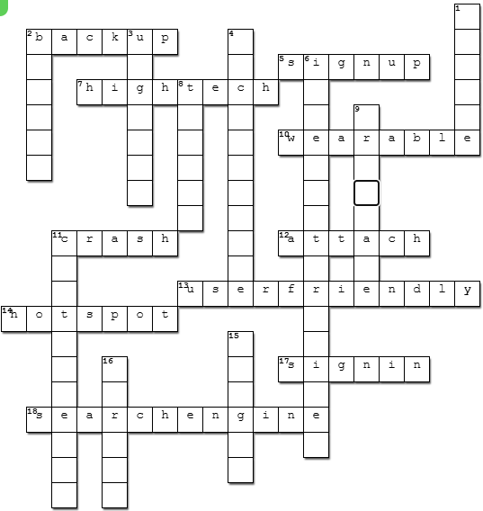
14. Wi-Fi
17. Enter account
18. Google, Bing, DuckDuckGo

